Rguthrie’s Bike Planner (name subject to change!)

Submission: Plan, Design, Research
Please submit by 2:30 pm Friday 2/14/2020 
- The project Idea,utility and purpose should be outlined in detail.

Idea: Full-stack application to provide users a tailored transit time for using Chicago’s Divvy bike-sharing system. The user’s demographic is used to mine the Divvy trips database to find trips between the same stations by users of similar age and gender, at similar time of day and similar season of the year.
Utility: The current Divvy app does not provide this information, which is useful for users in evaluating their short-term transit options as they need to move around the city.
Purpose: The purpose is to augment the Divvy app, which already shows availability of rental bikes by station, by providing the matched average transit time and a suggested route.

- A list of both team members expected roles on the project.

Team Dick comprises rguthrie, who will perform PM, architecture, design, and coding for all aspects of the Bike Planner app.

- A PDF, Screenshots or links to wire-frame page layouts for the application and Optional Flowcharts.

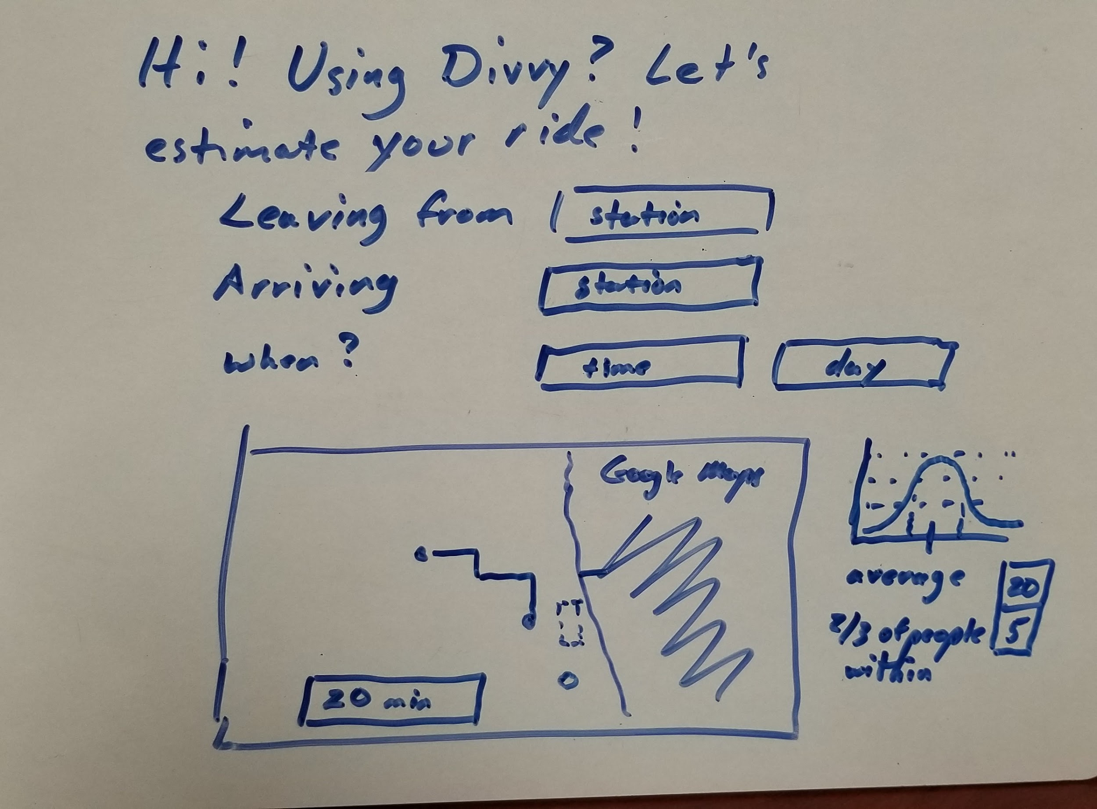
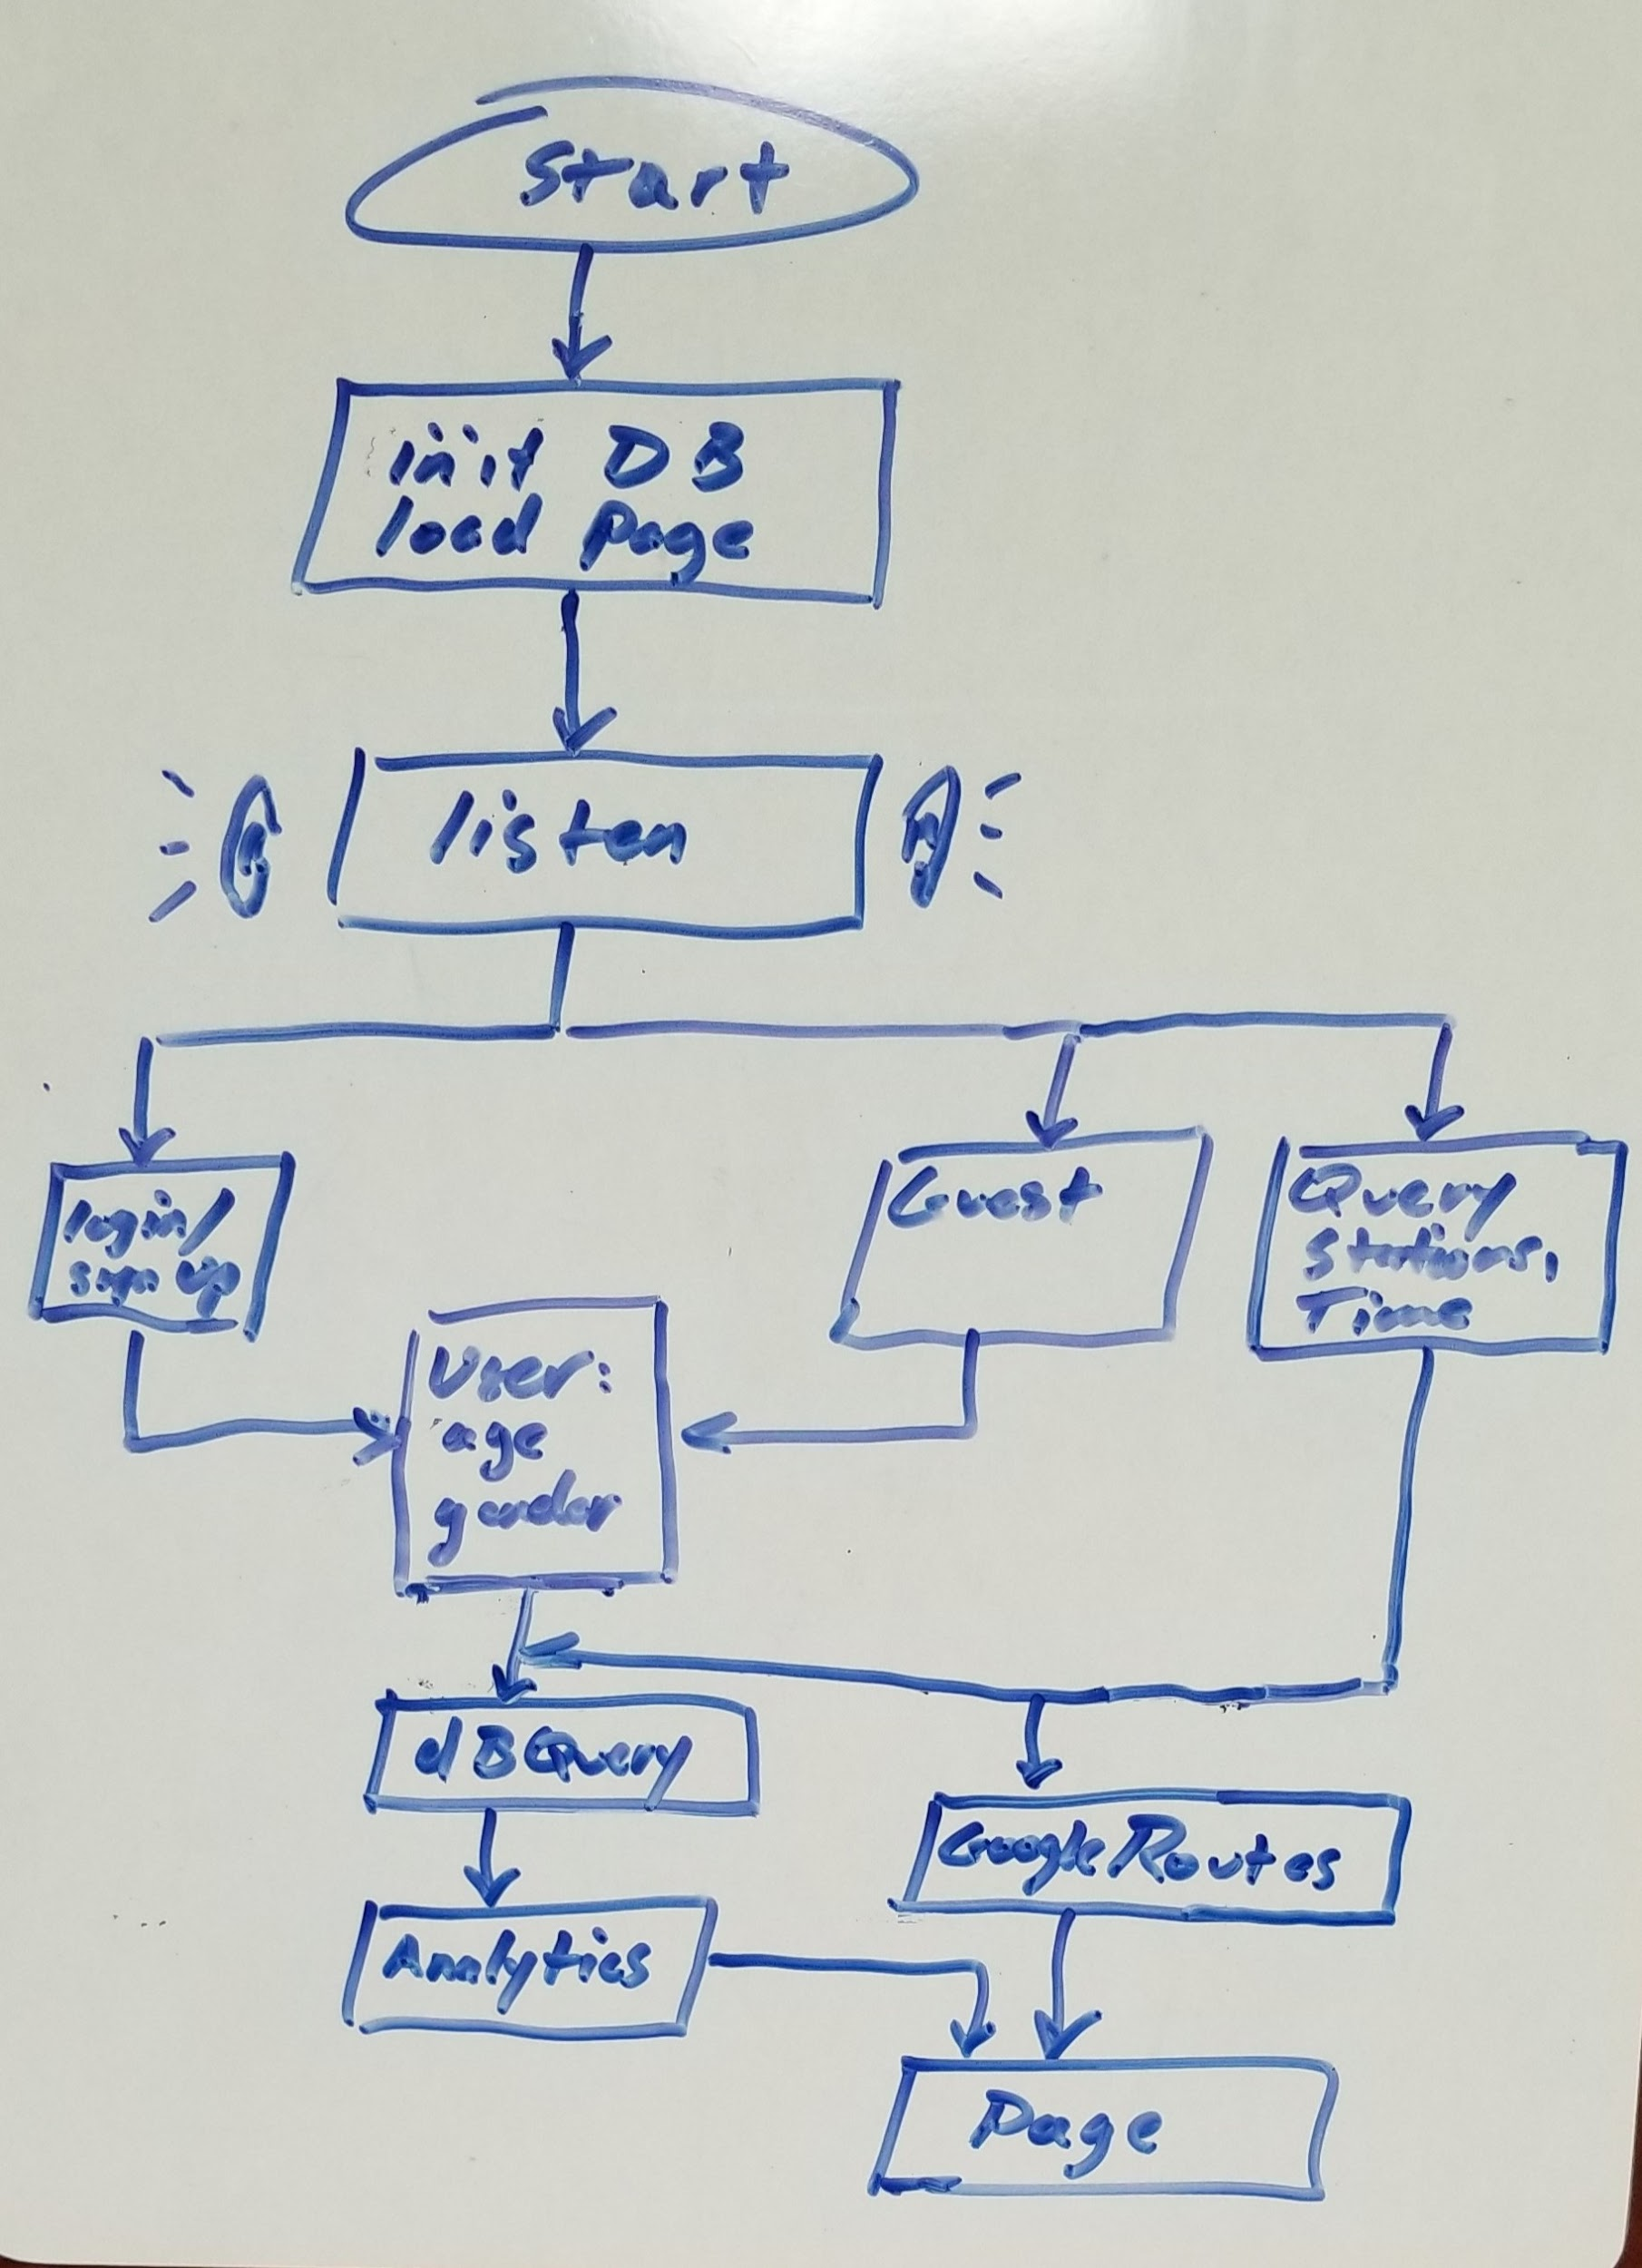

- A link to the repository.

https://github.com/rguthrie000/rguthrieBikePlanner.git

- A link to the project management board.

https://github.com/rguthrie000/rguthrieBikePlanner/projects/1?add_cards_query=is%3Aopen

